**LESSON 1 STRUCTURE OF A WORKSHEET (SPREADSHEET), FORMATTING AND DATA ENTRY IN EXCEL**

**POINT 1 INTRODUCTION**

In this lesson you will learn about the structure of an Excel worksheet and the basics of formatting and data entry. The application is widely used in companies and institutions, as well as by home users. It is mainly used to make calculations (e.g. expenditures) listed in a tabular form. In this use there are applied many logical functions (Lesson 3) mathematical, financial and database functions that are available in the program. Of a great importance is also semi-automatic copying of the created formulas using different variants of addressing (relative addressing, absolute addressing, mixed addressing). Excel is also used to create many types of charts (which we will learn about in lesson 2)which are useful e.g. in physics, mathematics and economics. It also contains a system of reports compilation in which the so-called pivot tables are used, used in the performance of business intelligence (Lesson 4).

**Learning outcome**

On having mastered the material of this lesson, the student should be able to easily enter and format data in Excel worksheets, make calculations (using operators and functions) and use semi-automatic duplication of the created formulas using different variants of addressing (relative addressing, absolute addressing, mixed addressing).

**Point 2**

**Structure of an Excel worksheet (spreadsheet) and entering and selecting data**

 Structure of a worksheet

Each document in Excel consists of **worksheets**.

An Excel worksheet (spreadsheet), is a two-dimensional grid with **columns** and **rows**. The column names are letters of the alphabet (A, B, C, …)and the rows are numbered chronologically (1,2,3 and so on).

The worksheet consists of cells i.e. small boxes, into which we can enter data. Each cell has its own address. We create it giving the name of the column and of the row in which the cell is located.

In the picture below cell A1 is selected.

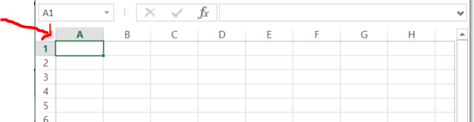

The address of a cell is always displayed on the left of the Formula Bar

Data entry

In Excel, we enter data directly into the cells. We click in the selected cell and begin typing. Entered digits will automatically move to the right side of the cell, and the text to the left. If we want to enter a decimal, we separate the integer from tens by a comma (never a dot!). This applies when we use the operating system with the Polish regional settings.

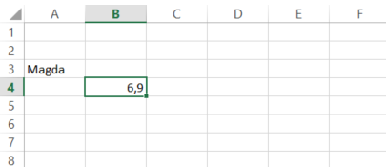

Selecting cells

Before copying or formatting cells we have to select them.

The cells can be selected as follows:

* to select one cell click in it
* To select one or more columns of cells, click on the column letter(s).
* To select one or more rows of cells, click on the row number(s)
* To select a group of contiguous cells, click in a corner cell and, with the left mouse button depressed, drag the cursor horizontally and/or vertically until all of the cells you want selected are outlined in black.
* To select multiple cells that are not contiguous, press and hold the Ctrl key while clicking in the desired cells.

CHECKING THE KNOWLEDGE:

In the picture below a cell is selected:

1. B2 (because, first we read the column letter, then the row number)
2. 2B

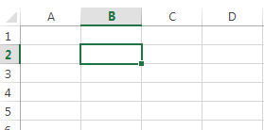

**POINT 3**

**FORMATTING CELLS**

In this lesson we will discuss the issue of cell formatting.

Basic formatting.

There are two ways of formatting the contents of the cells.

The first is to select the cells and in the formatting window choose the "Main Tools" tab, then we can change the visual and aesthetic part of the worksheet by selecting the appropriate formatting category tab from the existing formatting group ("Font", "Alignment", "Number" etc.)



The second way is to right-click in the selected cells and select Format Cells window. There are different formatting options available on different tab groups.

The first tab is Number and contains categories for the type of data that is in the cell. Select one of these to set the appropriate cell format.

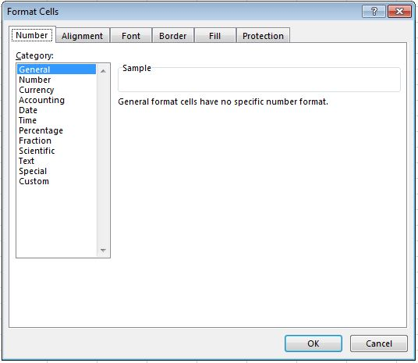

Applying different number formats, you can change the way of displaying numbers without changing them. The format of a number does not affect the actual value of the cell used in Excel to make calculations.

This value is displayed in the formula bar.

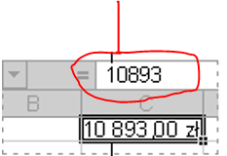

The following list contains information about available formats of numbers in the Number tab.

|  |  |
| --- | --- |
| **Examples of use** | **Format Description** |
| C:\WSI\ANG\budowa arkusza danych ANG obrazki\obraz_7.JPG | *General*  The default category when entering numbers in Excel is General. In most cases, formatted numbers are displayed as they were typed. However, if the cell is not wide enough to display the entire number and the actual value that Excel computes has a large number of decimal places the General format causes rounding the numbers off to 1 decimal point. In case of large numbers (12 or more digits) in the category General of Number tab scientific (exponential) notation is used. |
| C:\WSI\ANG\budowa arkusza danych ANG obrazki\obraz_8.JPG | *Number*  This formatting category is used for a general display of numbers. Here, you can specify the number of decimal places and how to display negative numbers, as well as decide whether to use a thousands separator |
| C:\WSI\ANG\budowa arkusza danych ANG obrazki\obraz_9.JPG | *Currency*  This formatting category is used to display numbers representing monetary values – together with the default currency symbol. Here, you can specify the number of decimal places and how to display negative numbers, as well as decide whether to use a thousands separator. |
| C:\WSI\ANG\budowa arkusza danych ANG obrazki\obraz_10.JPG | *Accounting*  This formatting category is also designed for displaying monetary values, but it aligns the currency symbols and separators of decimal numbers in a column. |
| C:\WSI\ANG\budowa arkusza danych ANG obrazki\obraz_11.JPG | *Date*  This format is used to display numbers of consecutive dates and times as date values in accordance with the determined type and regional settings. Date formats that begin with an asterisk (\*), include changes in regional settings of date and time that are made in the Control Panel. Settings in the Control Panel do not affect the formats without asterisks. |
| C:\WSI\ANG\budowa arkusza danych ANG obrazki\obraz_12.JPG | *Time*  This format is used to display numbers of consecutive dates and times as hours according to the determined type and regional settings. Time formats which begin with an asterisk (\*) include changes in regional settings of date and time made in the Control Panel. Settings in the Control Panel do not affect the formats without asterisks. |
| C:\WSI\ANG\budowa arkusza danych ANG obrazki\obraz_13.JPG | *Percentage*  The use of this formatting category results in multiplying cell value by 100 and displaying the result with the percent symbol (%). Using this format you can determine the number of decimal places to be displayed. |
| C:\WSI\ANG\budowa arkusza danych ANG obrazki\obraz_14.JPG | *Fraction*  In this format, the number is displayed as a fraction according to the selected type of fraction. |
| C:\WSI\ANG\budowa arkusza danych ANG obrazki\obraz_15.JPG | *Scientific*  In this format, the numbers are displayed in exponential notation, which means with the element E + n, where E (stands for Exponent) means multiplying the number displayed before that mark by 10 and raising it to n power. For example, the formatting category Scientific with two decimal places displays the number 12345678901 as 1.23 + 10, which is 1.23 times 10 to the power of 10. In this format you can determine the number of decimal places. |
| C:\WSI\ANG\budowa arkusza danych ANG obrazki\obraz_16.JPG | *Text*  In this formatting category the contents of the cell are treated as text and displayed exactly as they were entered, even if numbers are entered. |

On the Alignment tab we set Orientation and Text Alignment

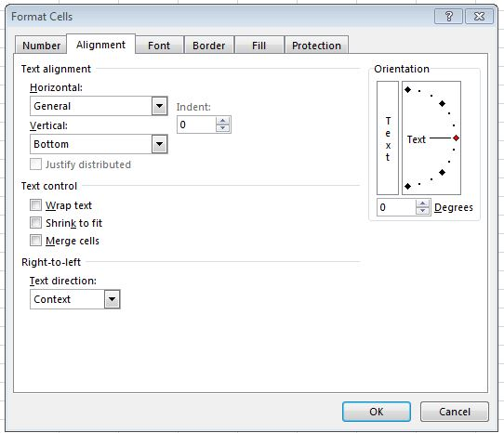

On the Font tab we set: Font name, Font style, Size, Color and whether you want the text to be underlined.

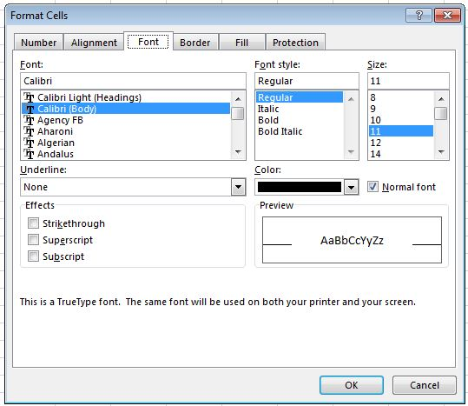

The fourth tab is Border. The Border tab provides a variety of border styles, To apply borders select the cells and then right-click and select Format Cells → Border. Select the border style and color first; then select the side or sides of the cell to receive the border.

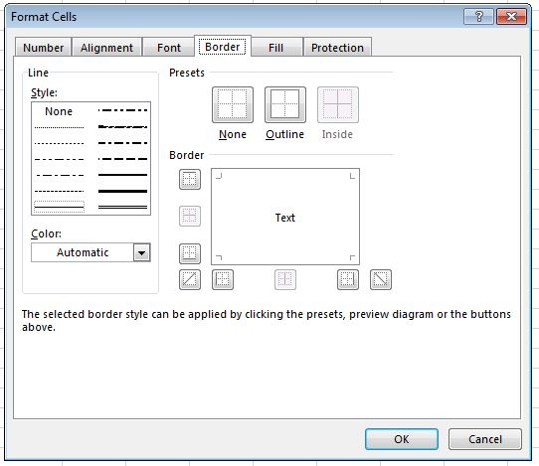

To change the background color of a single cell or range of cells, select Format Cells → Fill or Patterns depending on the version of Excel.

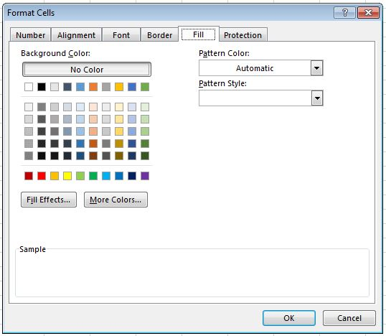

CHECKING THE KNOWLEDGE:

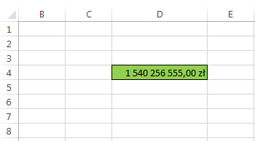

1. What types of formatting were used in the above picture:

a) Numbers -> Percentage, Font -> Arial

b) Numbers -> Currency, Border -> outline, Fill

(Currency symbol - zł at the end, green filling, outline border)

c) Numbers -> Fraction, Border -> outline, Fill

**Conditional Formatting**

Conditional formatting allows you to automatically format cells, when they fulfill a certain condition. We can e.g. change the font color depending on what grade point average the student has obtained and thus select students with an average of more than 4.75.

To apply conditional formatting should be:

• select the cells you want to format

• select Format → Conditional Formatting

• determine what condition are to be fulfilled

• set the appropriate formatting

• if there are more conditions, click the Add button

• If all conditions have been added, click the Format button

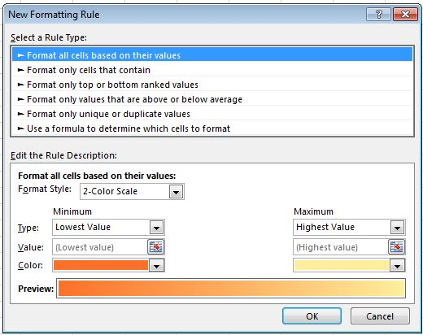

**Example**

There is often a need to highlight in the table some maximum or minimum values. This can be done by sorting the table, however, Microsoft Excel 2013 allows you to award the largest or smallest value without sorting.

At XYZ company an employee has to highlight the top 10 sales results.

First, you select the cells whose fragments you want to highlight. Then you choose **Conditional Formatting** in the **Main Tools**. In the menu that appears, you choose the option **Top/Bottom Rules**.

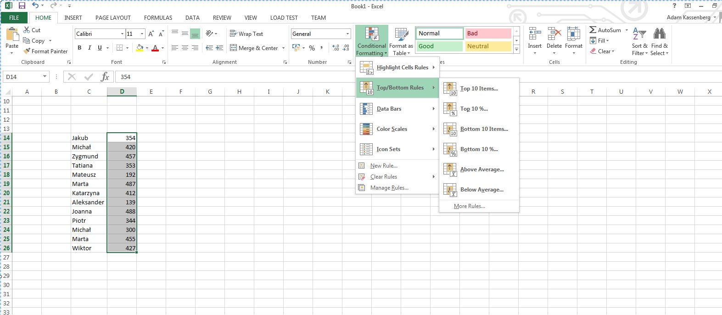

Click the **Top 10 elements** ... and in the window that appears, choose a value of 10 and the kind of distinctions.

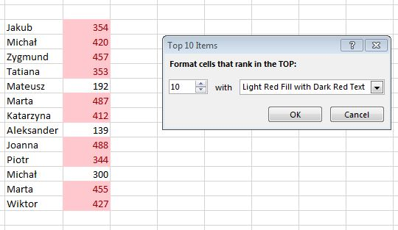

At the same spreadsheet denote the color blue 30% of the smallest value. You choose the option **Bottom** 10% ... in the menu **Top/Bottom Rules.** In the window, enter the value 30, and select the desired way of formatting. Since we do not have to choose blue color fill, select **Custom Format ...**

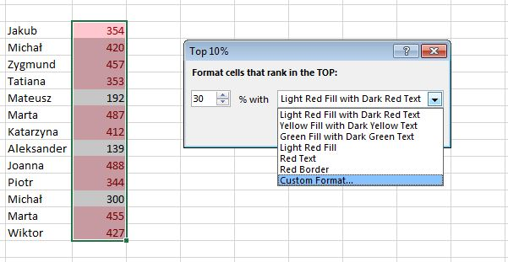

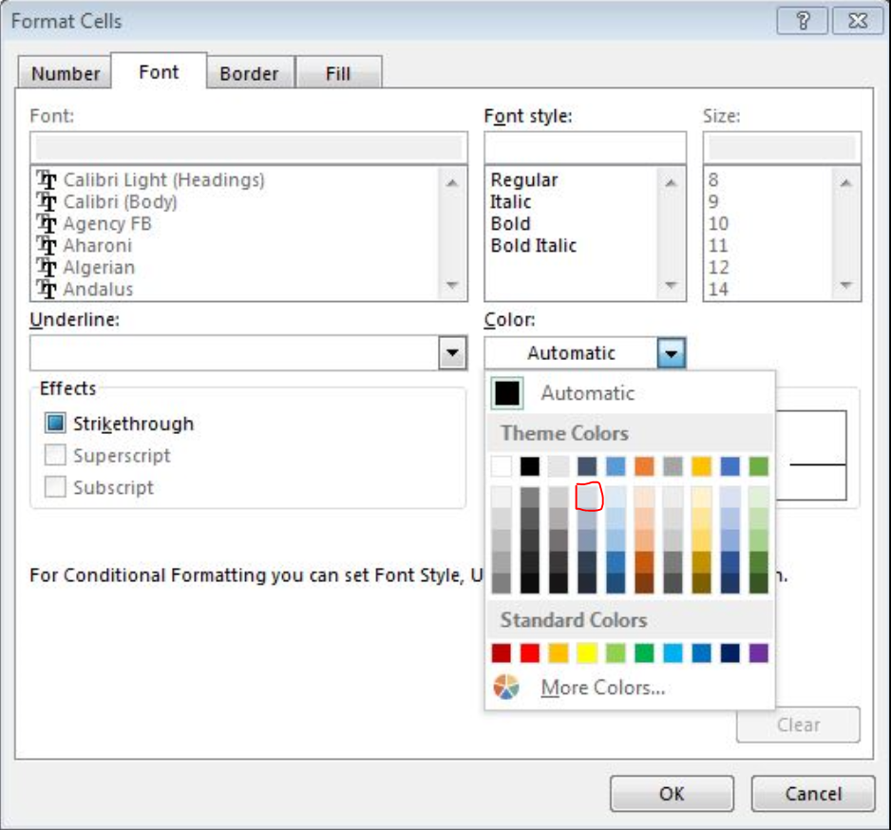

In the **Font** tab, **Color** option select a bright, visible on a dark blue background color. Then go to the **Fill** tab, where you choose the right color for the background.

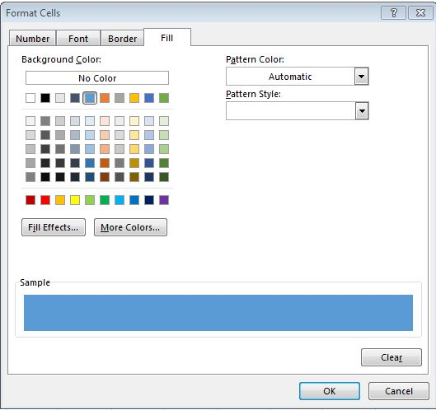

After approval of the changes by pressing **OK** you get a fully formatted spreadsheet.

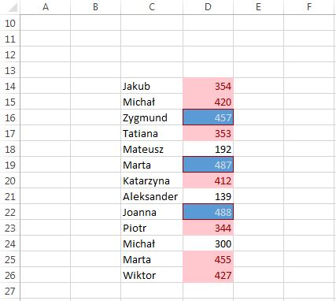

**Point 4**

**Calculations, operators and functions**

Performing calculations

Calculations performed using Excel formulas. To enter a formula proceed as follows:

⦁ click on the cell in which the formula is to be entered

⦁ enter the formula (action) starting from the "="

⦁ type the formula using cell references

⦁ approve the formula of the Enter key

When you perform all calculations in Excel it is recommended to use cell references. This makes it easier and faster to make adjustments, and speeds up the job when we have a few similar calculations.

The formula appears in the **formula bar**, and the result in an **active cell**.

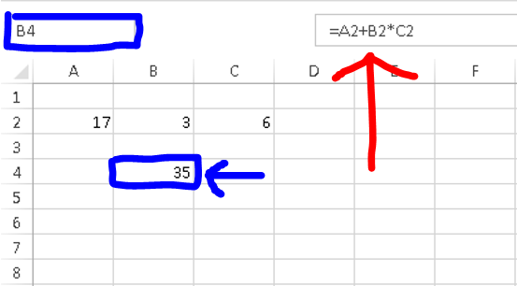

If you want to make amendments to the previously entered formula, click the cell in which the formula appears and make changes in the formula bar.

The formula can be copied between the cells in the example below to get, in rows two and three, the product from columns A and B enough to "catch" the element and stretch it down. More advanced rules to copy formulas will be presented in point 5.

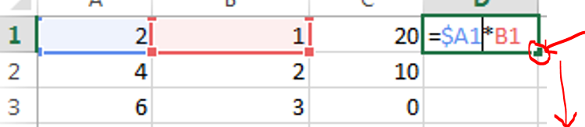

The cells can enter a formula using mathematical signs and pointing to the cells to be used in these calculations.

It is important to introduce the formulas which begin with the =

A collection of the most important operators and functions Excel spreadsheet:

|  |  |
| --- | --- |
| **Operator** | **Explanation** |
| + | Adding |
| - | Subtraction |
| \* | Multiplication |
| / | Divide |
| = | Equal |
| **<=** | Less than or equal |
| **>=** | Greater than or equal |
| <> | Different |
| ^ | Exponentiation |
| SQRT(x) | Returns the value of a positive square root |
| POWER(number;power) | Raises the number to the power |
| SUM() | Returns the sum the from the cells or range in brackets.  Example SUM(A1:A10) or SUM(A2;D3;G5) |
| PRODUCT() | Returns the product the from the cells or range in brackets.  Example PRODUCT(A1:A10) or PRODUCT(A2;D3;G5) |
| SUMSQ () | Displays the sum of the squares of the cells or range in brackets |
| EXP(x) | Returns **e** raised to the power of number.  The constant **e** equals 2.71828182845904, the base of the natural logarithm. |
| LN(x) | The natural logarithm of x. x > 0 |
| Log10(x) | Displays the logarithm |
| Log(number, base) | Returns the logarithm of the specific basis |
| PI() | Returns the value of π |
| RADIANS(angle) | Converts degrees to radians |
| DEGREES(kąt) | Converts radians to degrees |
| Sin(), Cos(), Tan() | Sine, Cosine, Tangent (function arguments must be given in radians |
| Ctg = 1/TAN() | Cotangent |
| FACT (n) | n!, n > 0 |
| COMBIN(n;k) | Displays the number of combinations of k - of element of a set of n - element |
| COUNTIF(range, criteria) | Counts the number of cells within the range that meet the given criteria |
| SUMIFS(sum\_range, criteria\_range1, criteria1, [criteria\_range2, criteria2], ...) | Adds all of its arguments that meet multiple criteria |

Examples

We already know the basic operators and functions of Excel. Now let us discuss a few practical examples:

1 .How to calculate ?

**Solution**: = 7 (1/4) = *7^(1/4)*

In Excel to calculate the root of grade 4 of 7 belong to convert it first to another character, because Excel does not provide a feature that allows you to calculate the root level 4 (during practical tasks often is the case, why should then remember the lessons of mathematics in school and properly transform equation).

2. Calculate the cos of 27 degrees.

As we know the arguments of trigonometric functions in Excel, should be given in radians. In that case, solution to the problem should look like this:

a)Transform 27 degrees to radians,

b)Put the result of the trigonometric function.

**Solution**: *Cos (radians(27))*

3. In how many ways can a 16 person group set in a series of pairs?

To calculate the result of this task should use the so-called permutations of a set: 16!

**Solution**: *FACT(16)*

4. In how many ways can you select a 6 person volleyball team from a 16 people group? It is indeed one of the most difficult tasks, therefore let's we apply the so called Newton's symbol:

 COMBIN(16;6)

5. How to calculate:



**Solution:** *sqrt(sin(radians (25))+ 2)/(cos(radians(45)+2)*

6. XYZ company employee was asked to count the total sales of the three products.

You enter data to Excel Sheet by selecting the cell and typing data directly **in the cell** or in the **formula bar** (indicated by arrows in the figure below).

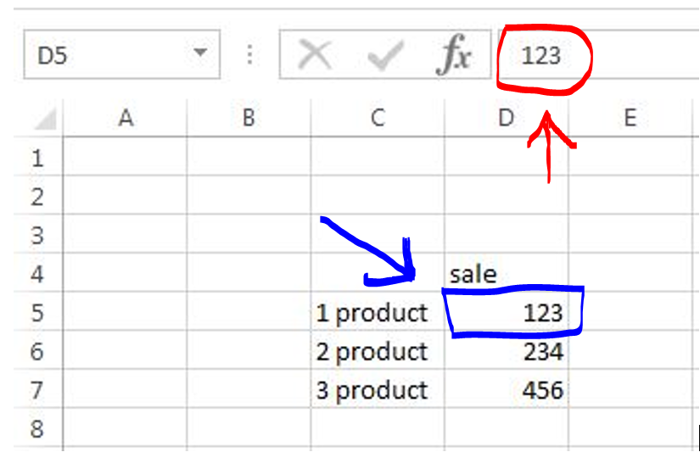

After setting the active cell D8 let's enter in the cell the formula summing sales of these three products. This can be done in many ways, for example by typing in D8 to the formula = SUM (**D5: D7**), or by entering = SUM (**and selecting the interesting range of the mouse**), but the best standing on the field select the icon of the sum, which is on the card 'Formulas'. The values you are searching for will be automatically summarized. The spreadsheet should look like as it is shown below.

In this way we can also introduce other functions - financial, logical and others.

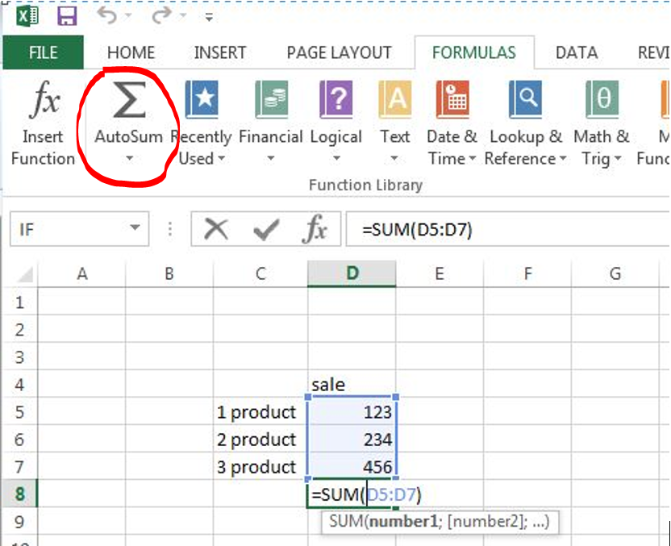

Checking knowledge:

1. In how many different ways can you select 3 people to go to the cinema out of a 7 person group? What formula will you type in Excel?

a) =COMBIN(7;3) - the symbol of Newton

b) =COMBIN(7,3)

c) =COMBIN(3;7)

**Point 5 The relative and absolute addresses**

As it has been mentioned earlier **cell ADDRESS** is a pair that specifies clearly a cell in the spreadsheet. It arises from the number of column and row sheet. The **columns** are numbered with successive letters A, B, C, and the **rows** - consecutive numbers 1,2,3; eg. a cell in the upper left corner of the sheet has the address A1.

Addresses of the cells act as variables in formulas (formulas called) entered into the worksheet cells. As a result, the change in value in 1-wszej cell can be automatically reflected in the other cells.

you can distinguish three types of addresses spreadsheet cells, typed into formulas - **their type is indicated by the $ sign**:

⦁ **Absolute** - in this addressing the specific cell address is important, not its position relative to other data. Add the cell address $ signs in front of the letter of the column and before the letter indicating the row eg. **$A$1**. As a result, the cell address will not change. Such addressing is used, for example when the value of a cell refers to a number of data:

**Example 1:**

An employee at XYZ has the task to calculate the price of goods in PLN in terms of Euro.

**Solution:**

*You will get this value by multiplying the price of the goods in Euro (B4:B12) by Euro exchange rate (in cell B1). To all the values in column B multiplied by this one particular cell must address it as an absolute address: formula takes the form:* ***=B4\*$B$1****. You can copy such a form without any changes.*

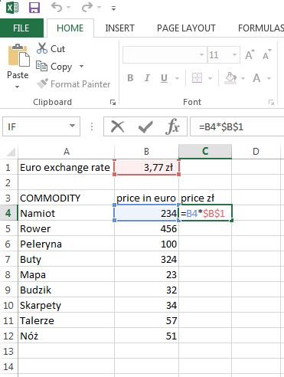

⦁ **Relative** - Addressing is used by the program as default. Addressing utilizes the relative position of the cells relative to each other and not their specific addresses. It is taken into account the position of the cell in which it is entered formula containing the address. Sheet remembers the location of the cells whose addresses appear in the formula, relative to the cell containing the formula. $ Character does not occur.

**Example 2:**

In columns A and B are the data series, in column D we obtain the products of the two pairs of the series.

**Solution:**

*To do this, in the cell D1, enter* ***=A1\*B1****, this formula can be copied to other cells in column D. This is possible thanks to this the program at that addressing only checks the relative position of the cell with the formula to each other, so the formula is copied down to the next cell will use a modified version of the formula as =A2\*B2 and so on.*

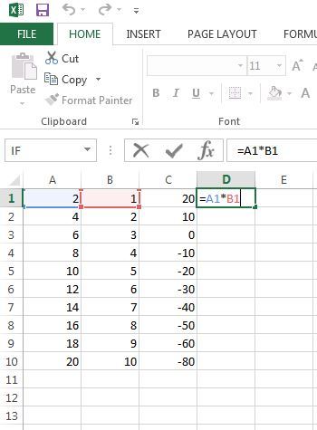

⦁ **Mixed** - Address mixed cell is a combination of an absolute and relative address. It is used when the values have to refer to a particular column or row. If we mean to indicate a specific example of the column address will be the character **$A1**, and in the case of a particular row becomes **A$1**. This distinction is important in the transfer (copying) formulas between cells. This part of the address, which is not subject to change should be preceded by a $; eg. the absolute address cell A1 has the form $A$1, and copying formulas with the address he remains always the same. In the mixed address only one part is preceded by a $ and does not change when you copy a formula.

**Example 3**

In column A the data to be multiplied by the value of the other two columns.

**Solution:**

To make such an operation should be time to enter a formula into cell *D1* ***=$A1\*B1*** and then copy it without modification to the other cells down or right, use addressing mixed in the form of: $=A1\*B1

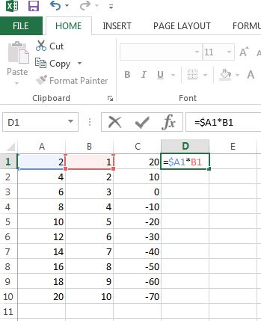

**CHECKING THE KNOWLEDGE:**

Which of the following formulas satisfies receiving the following multiplication table in two movements, copying the formula - the formula enter into the B2 and then copy to the right and the whole row down.

a) = A \* B $ 2 $ 1

b) = $ A2 \* B $ 1 (this option is correct because we multiply the value in the column by the value in the row)

c) = A \* B $ 2 $ 1

d) = $ \* $ A2 B1

e) = $ A $ 2 \* B $ 1

f) = $ A2 \* $ B $ 1

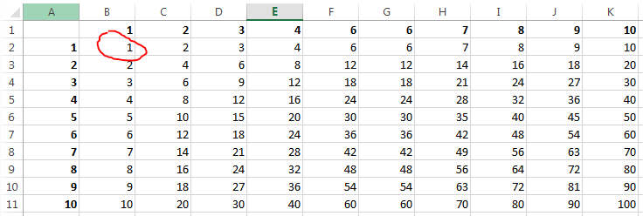

**Point 6. Summary**

In the above lesson we presented the basis for the introduction and formatting data in Excel spreadsheets, making calculations (using operators and functions) and the use of semi-automatic copying using different kinds of addressing (relative addressing, absolute addressing, mixed addressing). It should serve as a good kickstart in learning Excel spreadsheet.